1. Review from p.51 to p.70 in the text book.

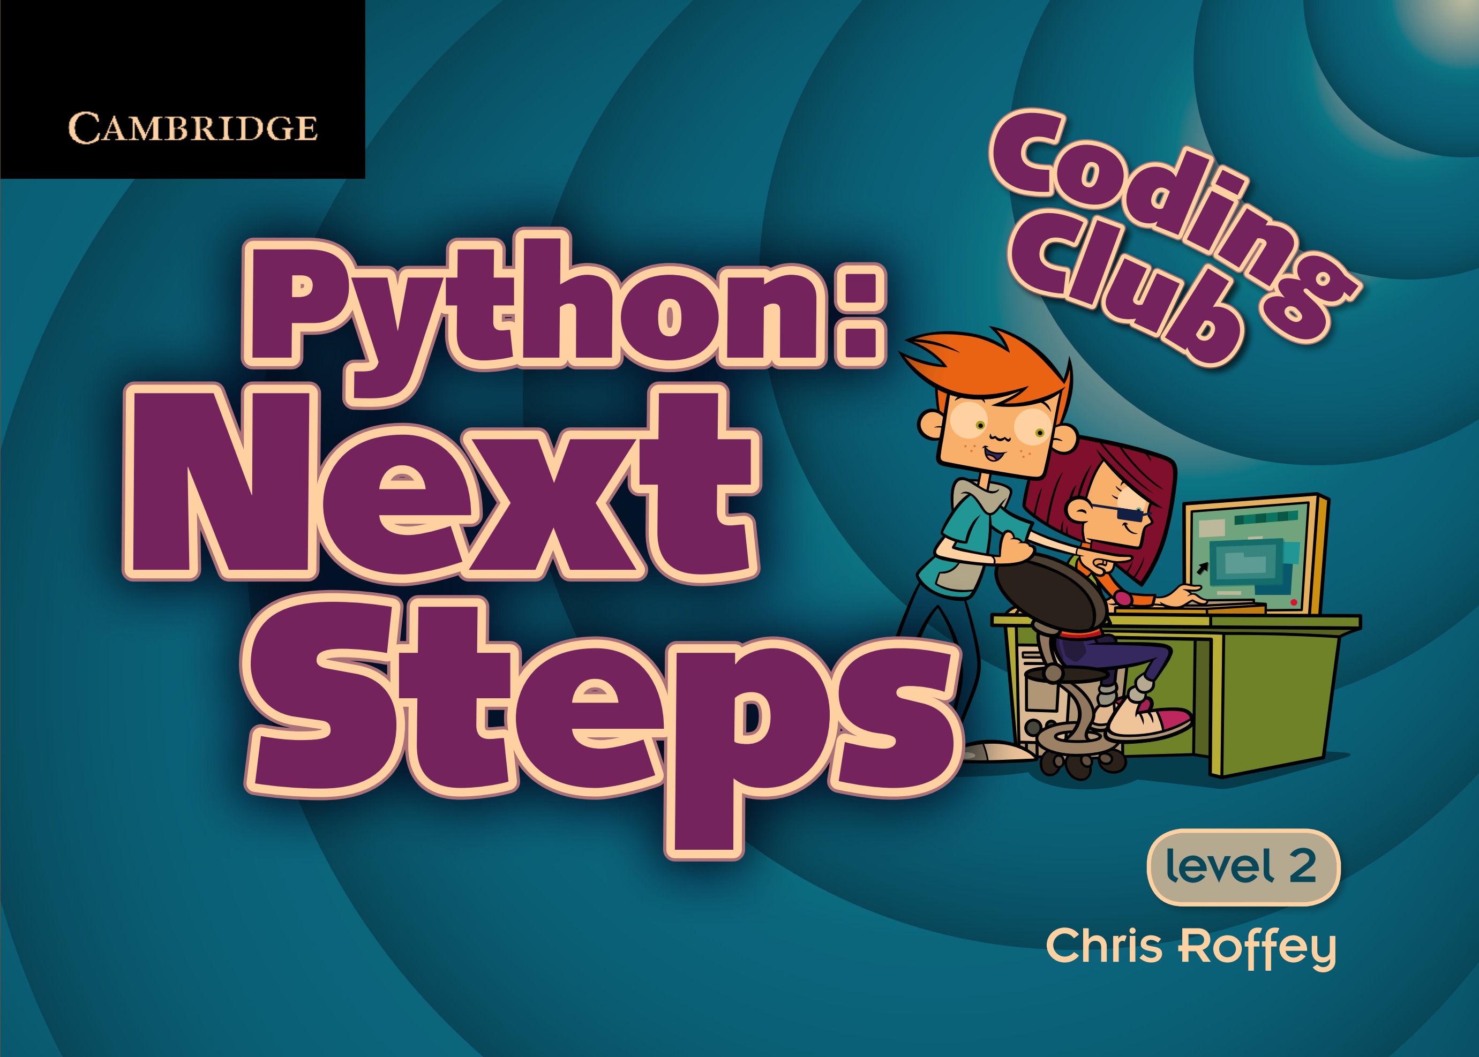

1. Summarize the concepts you think are important among these contents.